eBooks are Everywhere

# Creekside Tumblebooks Collection

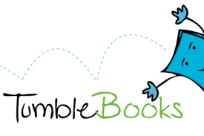

**Login:** creeksidenc

**Password**: books

# Pitt County Schools Overdrive CollectionScreen Shot 2017-08-03 at 10.31.08 AM.png

Read or listen on just about any device with your browser or in the app.

On PC or Chromebook - <https://soraapp.com/home>

On iPad or tablet or smartphone, download the Sora app from the App Store or Google Play store

Choose Pitt County Schools (Sora is Overdrive’s new app for school users)

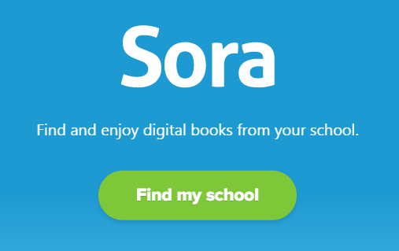 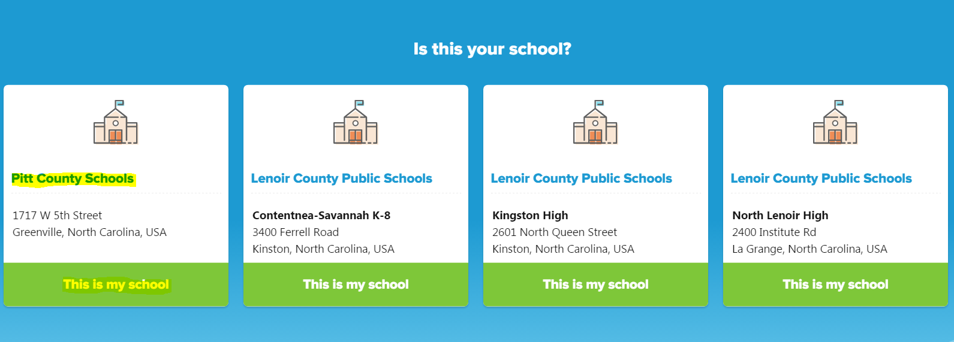

Log in with your network username and password (teachers and students)

Sora will also allow you to connect to public libraries but will only pull up Children’s and YA books.

Alternative for adults, navigate to <http://pittcs.lib.overdrive.com/> OR Search for Pitt County Schools in the OverDrive app (iOS or Android). Same login credentials.

Links on the district and school websites will be updated to the Sora site soon.

[Need more help getting connected?](https://help.overdrive.com/customer/portal/articles/1481729-getting-started-with-overdrive?_ga=2.38691882.848610816.1510584171-bd2a6dc8-74c3-4c9d-a00a-86b70ee902e9)

Currently: 220 titles and growing!

* **Elementary, middle or high school Battle of the Books** titles in ebook and/or audio book format
* Maker Space books
* NC Childrens’ and YA Book Award nominees
* Diary of a Wimpy Kid and other high interest books
* single user access with a 14-day checkout period
* Checkout period for audiobooks is 21 days, but use can adjust
* Overdrive books get "turned in" automatically after the checkout period, but you can renew for one additional checkout period and you can return early if you are done with the book (allowing access to other users in a more timely manner)
* Make requests from within the app
* Multi-user options for class use - email me or speak to your media coordinator

Let’s explore some features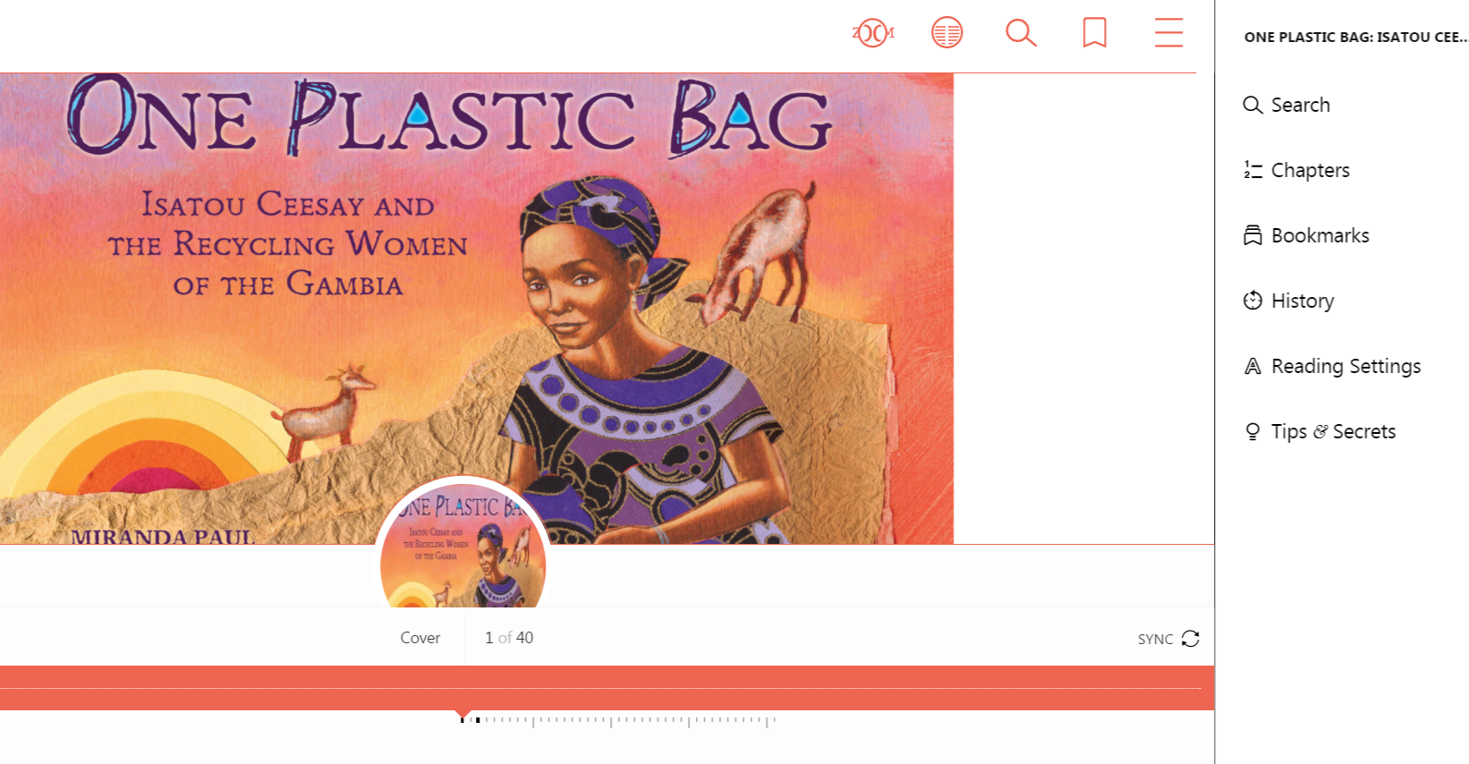

* Bookmark
* Highlight
* Notate
* Adjust font

[Promotional Materials](https://resources.overdrive.com/k-12-schools/marketing-outreach-digital/)

# 

# Farmville Public Library

Both students and teachers have digital access through this partnership, but the Farmville Library will also issue a card to anyone who lives or works in Pitt County.

Using the Sora App - open the menu and click “Add a public library.” Search for Farmville.

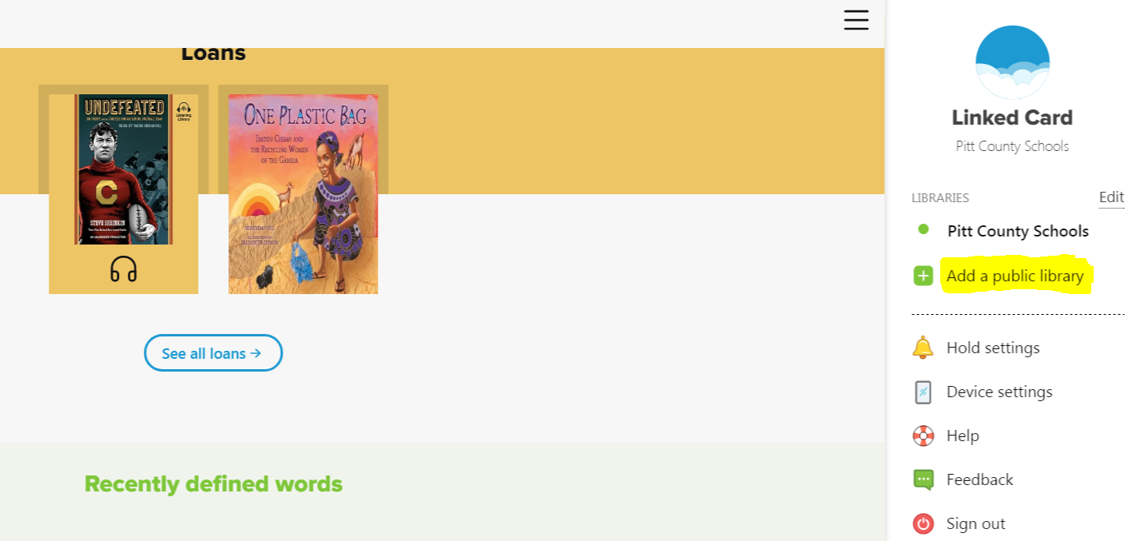 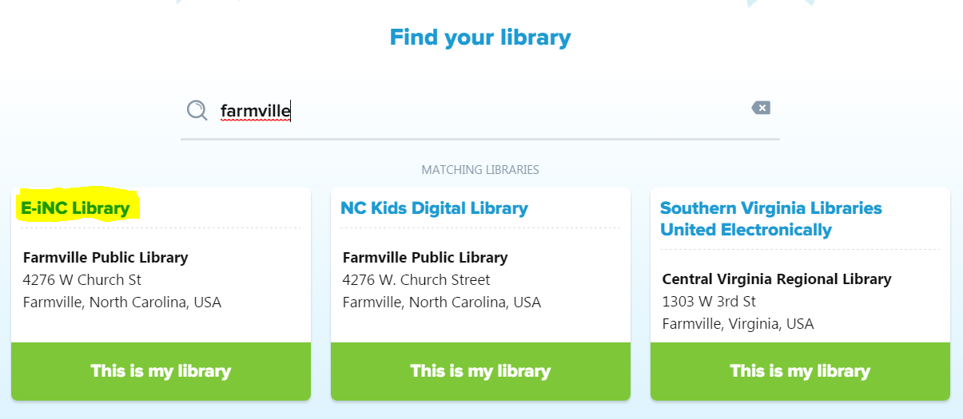

You don’t have to log in until you borrow a book. Select Farmville Public Library from the dropdown menu. Use your UID or Student ID for your library card number and the last four digits of your ID number as your PIN. 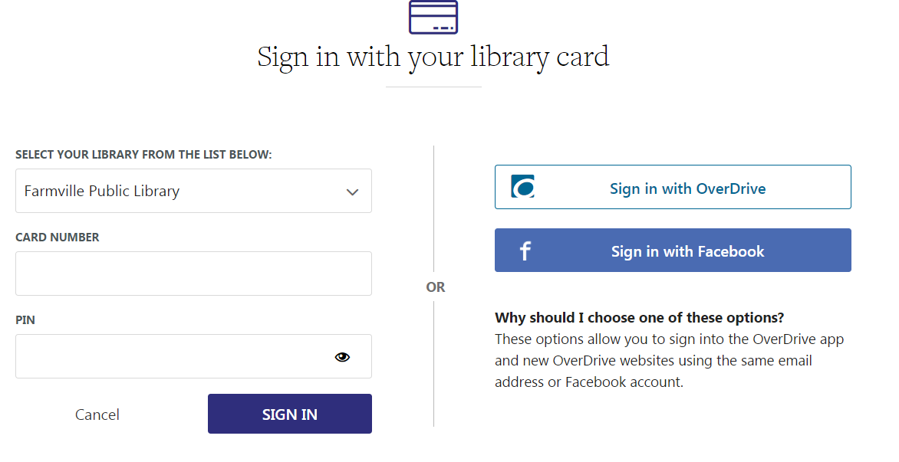

Both students and teachers have access.

Alternatively, navigate to [farmvillelibrary.org/home](http://farmvillelibrary.org/home). Keep in mind, this route allows access to all content, not just content for children.

When you hover over the ebooks button, you will see three choices: Overdrive, NC Digital Kids, and Homegrown Collection. Access to the NC Kids collection is covered next in this document.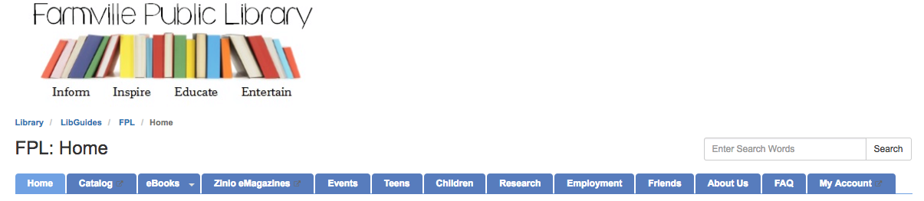

The Homegrown Collection from NC LIVE is primarily aimed at adults, but may be useful for high school students.

When you select Overdrive, you will be taken to this page:

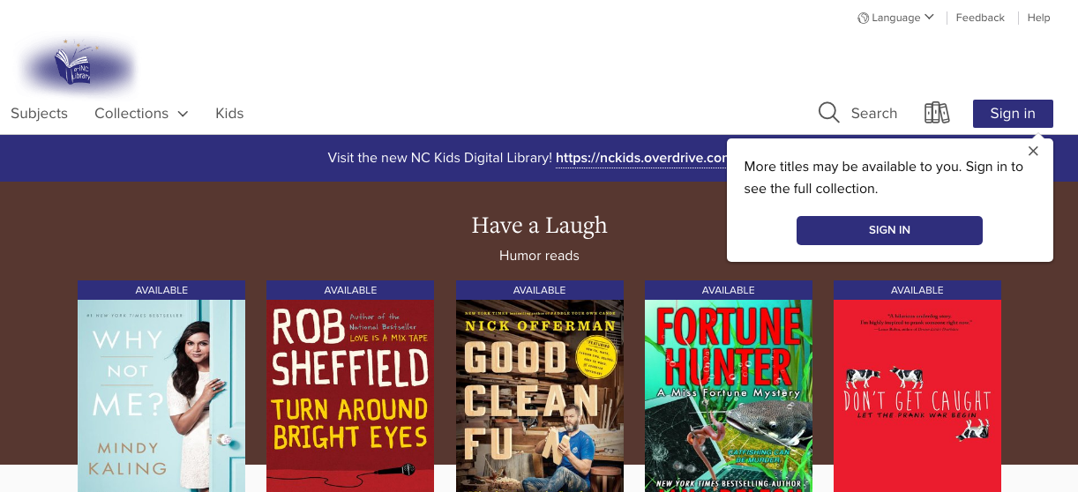

At the Sign-In screen, enter your UID or Student ID for your library card number and the last four digits of your ID number as your PIN.

Once into the program, you can browse the collection or choose to go to the NC Kids collection.Notice in the top left hand corner of the home screen, there is a KIDS link. This will take you to Farmville Library's children's ebook collection. These are in addition to the NC Digital Kids collection.

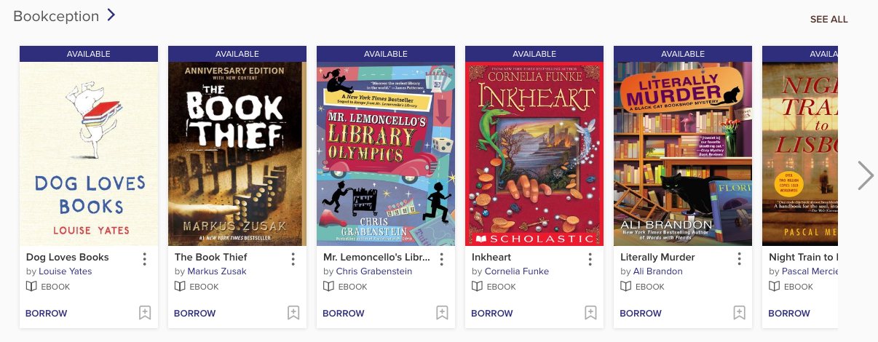

Since these are Overdrive books, they function similarly to the PCS ebooks.

Explore the collection, sample some titles, and try out the reading settings and features. Share any useful features you find.

# NC Digital Kids Library

* For NC children pre-K through middle school
* Over 3,700 eBooks, audiobooks, videos and Read-Alongs
* accessible through [custom website](https://nckids.overdrive.com/) or the one of the Overdrive apps
* All you need is a library card and for Pitt County school children, your student ID serves as your library card!

**Using the Sora App** - open the menu and click “Add a public library.” Search for Farmville, then follow the same process as you before, but this time you will chose NC Kids Digital Library.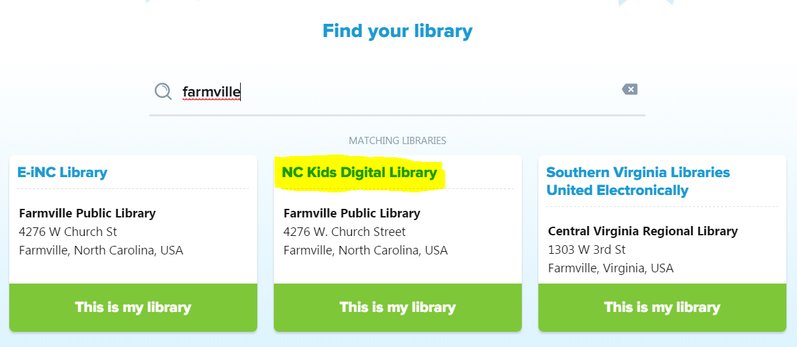

You can also search for Sheppard Library, but the credentials are different. They are included in the section below.

**Using the website**

* [Go to https://nckids.overdrive.com/ 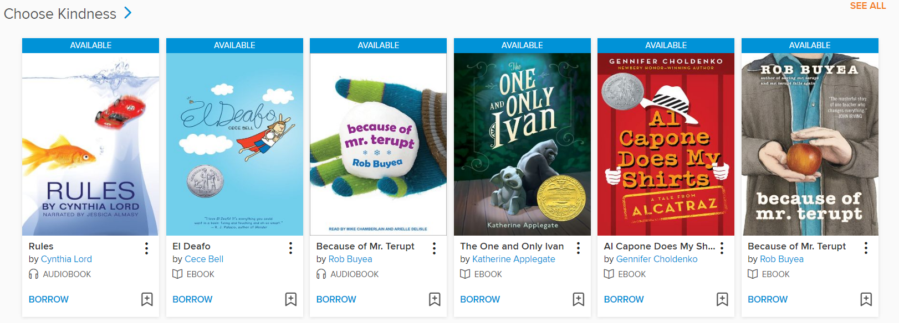](https://nckids.overdrive.com/)
* Click on Sign In button in top right hand corner
* In drop down menu, select Farmville Public Library or Sheppard Memorial library
* If you choose Farmville, enter your student ID for library card number and the last four digits of your student ID as your PIN.
* If you choose Sheppard, enter your student ID as your library card number (no PIN required). Teachers must have a library card number.
* Sign In
* Explore all the digital content available!
* For more information about NC Kids Digital Library, [click here](http://statelibrarync.org/ldblog/2017/02/02/announcing-nc-kids-digital-library/).

# NC Wiseowl EBSCO eBook CollectionsScreen Shot 2017-04-11 at 11.46.45 AM.png

Navigate to [www.ncwiseowl.org](http://www.ncwiseowl.org/) or your school may have a link or network icon for you to follow.

Choose the appropriate grade level area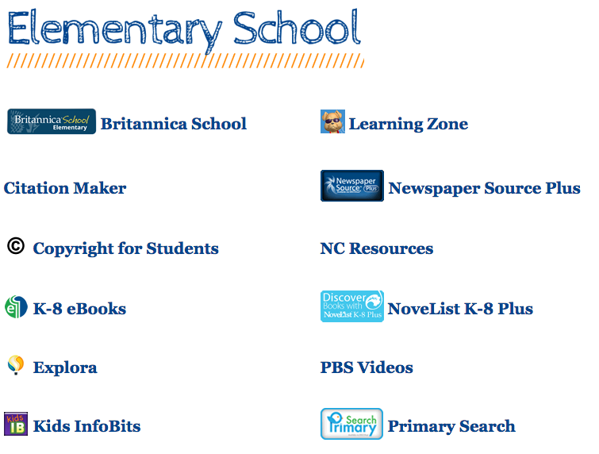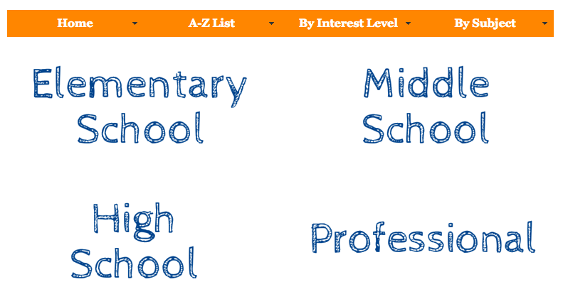

# Next, select eBook K-8 Collection or eBook High School Collection

# At school you will not need a password. For home use, see your media coordinator for the password.

# eBooks will also show in search results if you select EBSCO Host or Explora

Highlights

* Easily read in your browser online
* Most items have unlimited access and some degree of print/copy/save/email permission
* Create a login to save items to a folder
* Use a built-in dictionary, easily cite excerpts, and connect to Google Drive and Classroom
* Email, print or share a certain number of pages
* Use the controls at the bottom left screen of an open book to control its view/size?
* Download for offline access
  + On a tablet or phone, you need the Bluefire Reader app for downloading

# Search for an eBook you can share with your students or fellow teachers

# 

# 

# Sheppard Memorial Library - One Click Digital eBooks

Navigate to <http://sheppardlibrary.org/home>

Locate the RB Digital icon in the left side column and click on it.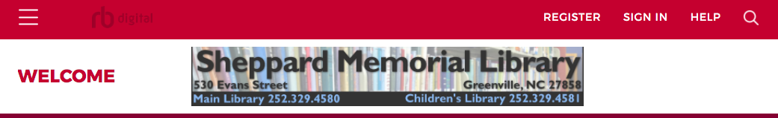

Go to the Register link at the top of the page

Use your student ID number as your library card and your 8-digit birthdate as your PIN. Create a username and password and enter some personal information such as your name, email address and zip code. Adults need a library card to do this.

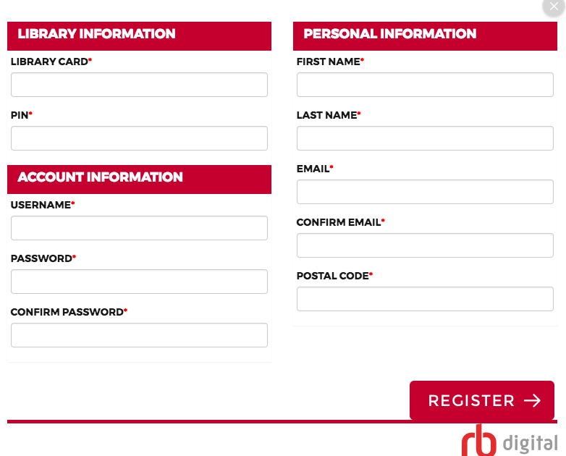

Once you are registered you can use the Sign In button and begin checking out ebooks and audiobooks on your computer, tablet or phone. I recommend downloading and reading/listening on one of the mobile device apps as they are much easier to use and also allow you to checkout.

Here is a tutorial for getting started with the app: <https://vimeo.com/134971098>

# Three Noteworthy Free Sources of eBooks:

**Epic -** [**www.getepic.com**](http://www.getepic.com)

* Free to educators
* Can set up class/student accounts
* Create assignments and quizzes
* What’s the catch?
  + They want you to share with parents so they can offer the paid version to families

**Unite for Literacy -** [**www.uniteforliteracy.org**](http://www.uniteforliteracy.org)

* Completely free
* For emerging readers
* 40 languages and narration

**Gutenberg Project -** [**https://www.gutenberg.org/wiki/Main_Page**](https://www.gutenberg.org/wiki/Main_Page)

* Over 57,000 free public domain books
* Primarily books published before 1923